PH 250B Week 11 Effect Modification
Topic 1: Biologic interaction, statistical interaction, effect modification
Practice Problems

Problem 1. (Fall 2017 250B Problem set)
An investigator conducted a one-year case-control study of the relationship between gender and coronary heart disease (CHD). Because of prior work, the investigator believed that the role of a subject’s level of serum ferritin (an iron-binding protein) must also be evaluated in any analyses. The stratified results are below.
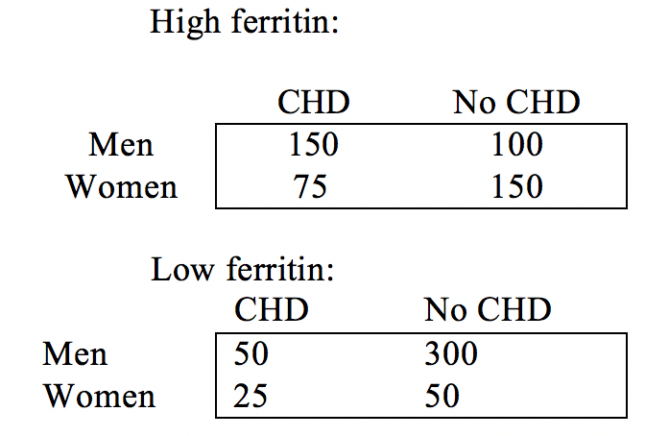
- Calculate and interpret the OR for each table (low and high ferritin).

- Calculate and interpret the crude OR_{pooled} for the combined data.

- Calculate and interpret the Mantel Haenszel OR_{MH} adjusted for ferritin levels.

d. Is there statistical evidence of heterogeneity? Calculate the X² test of homogeneity and use this information to describe the role of ferritin in the relationship between gender and CHD.

e. Is the adjusted measure of association (the OR_{MH}) useful in this situation? Why or why not?

f. How should the investigator present these findings? Write a one or two sentence abstract of the results.

Problem 2. (Fall 2017 250B Practice exam problem set)

The following questions use data and situations adapted from: Nickson C, Mason KE, English DR, Kavanagh AM. Mammographic screening and breast cancer mortality: a case-control study and meta-analysis. Cancer Epidemiol Biomarkers Prev. 2012 Sep;21(9):1479-88.

This study was designed to investigate the association between mammograms and breast cancer mortality among women over the age of 50. “Cases” were breast cancer patients who had died as a result of their cancer, and “controls” were women who were still living at the time of the study, regardless of their breast cancer diagnosis. Participants were categorized as “exposed” if they had received at least one mammogram any time after their 50th birthday. The investigators collected the following data:

 | Cases | Controls
Exposed | 167 | 2051
Unexposed | 264 | 1599

The investigators were also concerned that socioeconomic disadvantage might be a potential confounder or effect modifier. They measured SES and found the following:

Low SES:
 | Cases | Controls | Total
Exposed | 56 | 1095
Unexposed | 131 | 1107
Total |  |  | 2389

High SES:
 | Cases | Controls | Total
Exposed | 111 | 956
Unexposed | 133 | 492
Total |  |  | 1680

a. Calculate the crude OR and the stratum-specific ORs for those with low and high SES. (3 points)

b. Calculate and interpret the adjusted OR. (3 points)

c. The p-value on the chi-squared test for homogeneity is 0.98. State the null hypothesis being tested. Given these results, what do you conclude about the role of SES? Is it a confounder, effect modifier, or neither? Justify your answer in 1-2 sentences. (3 points)

Problem 3. (Fall 2017 250B Practice exam problem set)
Investigators of a cohort study examining the relation between vegetarian diet and incident myocardial infarction (MI) drew a DAG at the beginning of their study, consulted the existing literature, and identified height as a confounder and also potentially an effect modifier of this relation.

The investigators calculated an overall CIR of 0.45 for the relation between vegetarian diet and incident MI. They then stratified by height, and found a CIR=0.82 for people less than 5’6” and a CIR=0.83 for people 5’6” and taller.

Answer the following questions.

A. In the relationship between vegetarian diet and incident MI, height appears to be (circle one) (2 Points):

a) neither a confounder nor an effect modifier.
b) a confounder but not an effect modifier.
c) an effect modifier (confounding is irrelevant).

B. What measure(s) of association would you recommend that the investigators report given the role of height you identified in A) in the relation between vegetarian diet and MI, and why? (3 Points)

Problem 4. (Fall 2017 250B Practice exam problem set)
You are given some data on work stress and cardiovascular disease (CVD) and told to analyze the relationship between these two variables. You think that rural residence might be an effect measure modifier of this relationship. Below are the actual data.

 | Rural |  |  |  |  | Non-rural
 | CVD | No CVD |  |  |  | CVD | No CVD
Stressed | 154 | 618 | 772 |  | Stressed | 151 | 470 | 621
Non-stressed | 360 | 2409 | 2769 |  | Non-  stressed | 418 | 2372 | 2790
 |  |  | 3541 |  |  |  |  | 3411

A. Calculate the crude CIR. (1 Point)

B. Calculate the CIR for each group (rural and non-rural separately). (2 Points)

C. Calculate the chi square test of homogeneity to assess whether rural residence is an effect modifier of the work stress -> CVD relationship. (4 Points)

Useful information:
var(ln(CIR_{rural}))=0.00761
var(ln(CIR_{non-rural}))=0.00705

D. Use the p value table below to determine an approximate p value based on your test statistic.

X² table
P-value
Df | 0.025 | 0.050 | 0.200 | 0.500 | 0.750
1 | 5.02 | 3.84 | 1.64 | 0.455 | 0.1015
2 | 7.38 | 5.99 | 3.22 | 1.386 | 0.5754

E. State the null hypothesis for this X² test, and interpret your finding in relation to this null hypothesis. (3 Points)

F. Do these results reveal anything about causal interaction? Why or why not?
Assume that your results are unbiased. (3 Points)

